

PERIODIC TEST 1 (2023-2024)
SET 2
Subject: Sociology  Grade: XII | Max. Marks: 35  Time: 1.10 hrs.
Name: |  | Section: | Roll No:
General Instructions:
- 1. The question paper is divided into four sections.
- 2. There are 18 Questions in all. All Questions are compulsory.
- 3. Section A includes question No.1-11 carrying 1 mark each.
- 4. Section B includes question No. 12-14 very short answer type carrying 2 marks each. Answer to each question should not exceed 30 words.
- 5. Section C includes question No.15-17. They are short answer type questions carrying 4 marks each. Answer to each question should not exceed 80 words.
- 6. Section D includes question No.18. It is a long answer type question carrying 6 marks. Answer to each question should not exceed 200 words.

1 | Which is the state with maximum sex ratio in India?  a. Chhattisgarh  b. Karnataka  c. Kerala  d. Odisha | 1
2 | Which of the following facts, the fertility rates of a country is related  a. Number of women in the child -bearing age group  b. Number of married women among them  c. Capacity of fertility among them  d. All of the above | 1
3 | The changing age structure offers a demographic dividend for India. Identify from the following choices, the relevant age range that allows for demographic dividend.  a. 0-14  b. 15-64  c. 64-75  d. 75 and above | 1
4 | Assertion (A)- More and more people who live in villages are migrating to cities and urban areas.  Reason (R)- This flow of rural urban migration is due to economic reasons only.  - Both A and R are true and R is the correct explanation of A  - Both A and R are true but R is not the correct explanation of A  - A is true but R is false  - A is false but R is true | 1
5 | Assertion (A)- It is striking that the lowest child sex ratios are found in the most prosperous regions of India.  Reason (R)- Prosperous families decide to have fewer children often only one or two now they may also wish to choose the sex of their child.  - Both A and R are true and R is the correct explanation of A  - Both A and R are true but R is not the correct explanation of A  - A is true but R is false  - A is false but R is true | 1
6 | Positive checks on population growth can include:  - Warfare  - Famine  - Disease  - Sterilization  - A only  - Both a and b  - A,b and c  - All of the above | 1
7 | Correct the given statement:  The National Family Planning Programme was renamed as the National Population Programme | 1
8 | ______ was a systematic collection of data of people residing in a specific territory. | 1
9 | State Whether True or False: China conducts regular censuses.  - True  - False | 1
10 | State whether True or False: Agriculture production grows in Geometric Progression.  - True  - False | 1
11  12 | ______ refers to the estimated number of years that an average person is expected to live.  Differentiate between Formal and Social Demography. | 1  2
13 | Why is rising dependency ratio a cause for worry in countries that are facing an aging population? | 2
14 | Define ‘Replacement Level’? | 2
15  16 | State & critically analyze the Malthusian theory of population change.  Describe in brief about the variation in literacy rate across Gender, region and Social Group. | 4  4
17 | Study the given graph and answer the following questions:  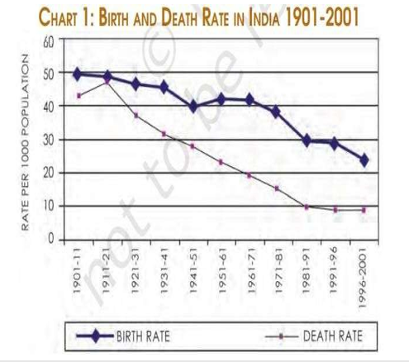  - Number of live births per thousand population is termed as ____  - Birth Rate  - Death Rate  - Fertility Rate  - Sex Ratio  - From the above given graph, in which year the growth rate of population substantially increased?  - 1941-1951 to 1951-1961  - 1911-1931 to 1931-1941  - 1911-1921 to 1931-1941  - 1931-1941 50 1941-1951  - In which year, death rate is equal to the birth rate in the above Graph?  - 1941-1951  - 1931-1941  - 1951-1961  - 1911-1921  - Which of the following is not a factor of declining Death Rate?  - Malnutrition  - Adequate immunization centers  - Famine  - Pandemics | 4
18 | What is meant by sex ratio? What are some of the implications of a declining sex ratio? Do you feel that parents still prefer to have sons rather than daughters? What is your opinion, could be some of the reasons for this preference. | 6

